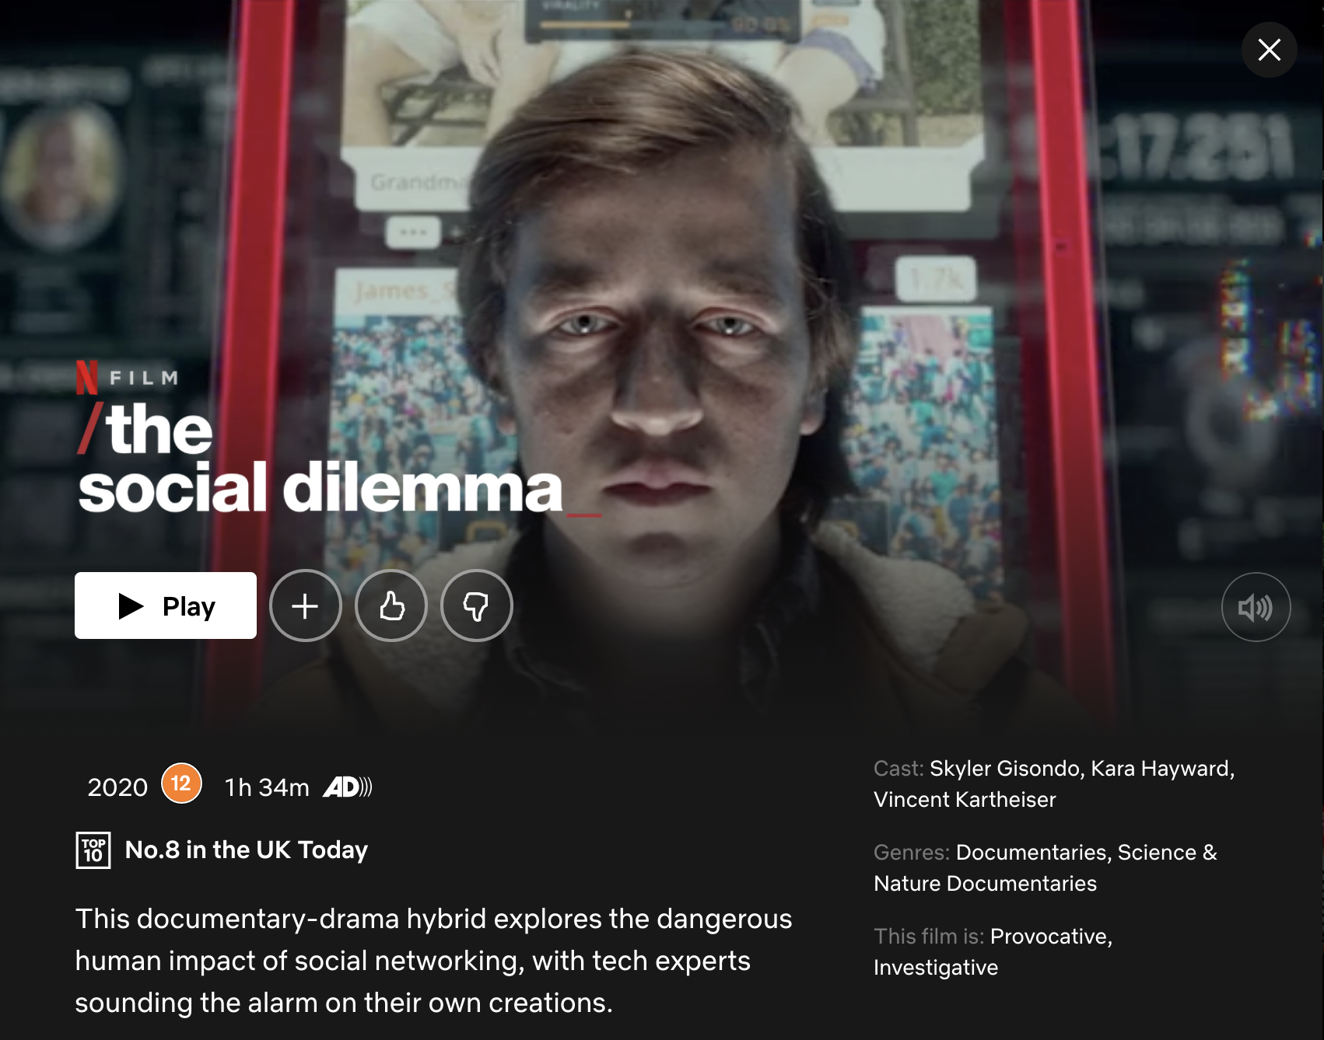
- What is the name of the documentary?
- What year was it released?
- Why do you think that they released the documentary when they did?
- Why did they include a quotation at the start of the documentary?
- What do we see in the opening of the documentary?
- Why do you think they started with this content?
- Why did they edit archive content/clips into the opening sequence?
- What is the tone of the music throughout the opening?
- What mode of address do they use in the interview footage?
- Why do you think they used this technique?
- How do they introduce/establish the first interviewee?
- Why introduce them in this way?
- What does the animated content bring to the story?
- What environments/locations are the interviews filmed in? Why do you think they chose these locations?
- Why did they use reconstructed scenes?
- How did they emphasise the key points?
- What key message are the filmmakers trying to communicate?
- How does the documentary conclude?
- Why end the documentary in this way?
- What do you think the 3-act structure is for this documentary?

