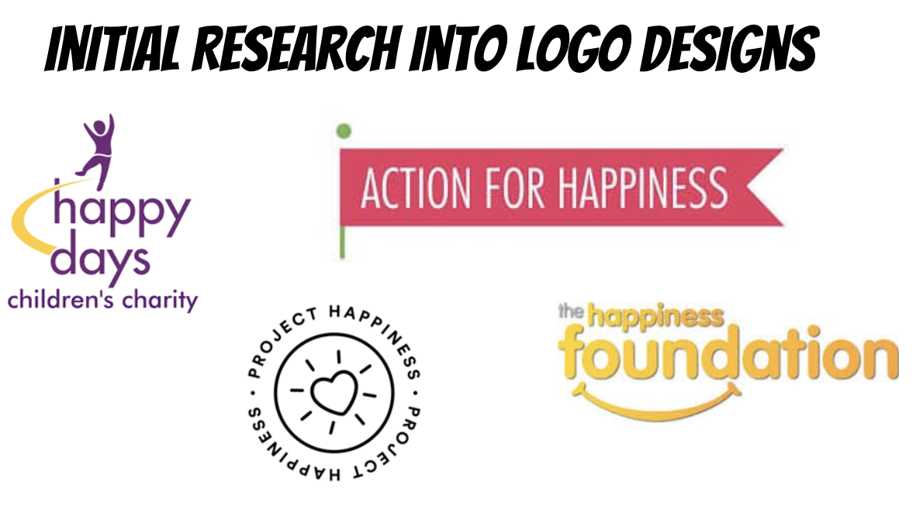
Happy Days Logo:
What vibe does the logo communicate?
Do the colours signify happiness?
Are the images/graphics in line with the happiness theme?
Is the typography appropriate for the brand?

Action for Happiness Logo:
What vibe does the logo communicate?
Do the colours signify happiness?
Are the images/graphics in line with the happiness theme?
Is the typography appropriate for the brand?

Project Happiness Logo:
What vibe does the logo communicate?
Do the colours signify happiness?
Are the images/graphics in line with the happiness theme?
Is the typography appropriate for the brand?

The Happiness Foundation Logo:
What vibe does the logo communicate?
Do the colours signify happiness?
Are the images/graphics in line with the happiness theme?
Is the typography appropriate for the brand?

