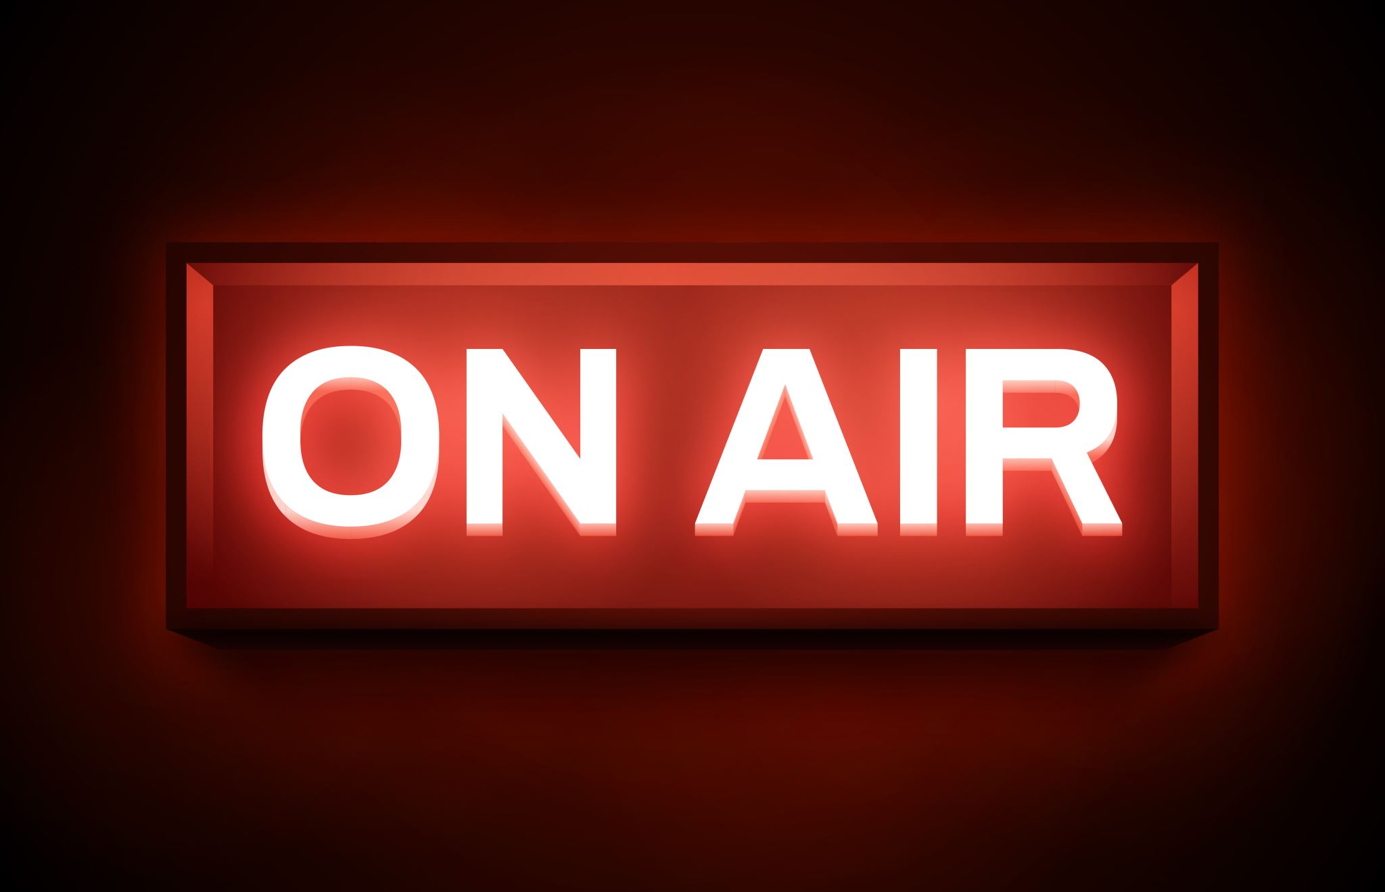
Technical Reflection of Test Interviews
- What did you try to achieve?

- What problems/challenges were you faced with during the recording process?

- How did you try and overcome these?

- What problems/challenges were you faced with during the editing process?

- How did you try and resolve these?

- How good ...
- Are the audio levels?
- Is the clarity of speech?
- Is there any distortion?
- Is there lots of background/unwanted noise?
- Does the interview flow well? Why or why not?
- Does the interview fulfill its purpose?
- Is it suitable for the target audience?

- How would you improve this product next time?

