Planning an Interview Worksheet
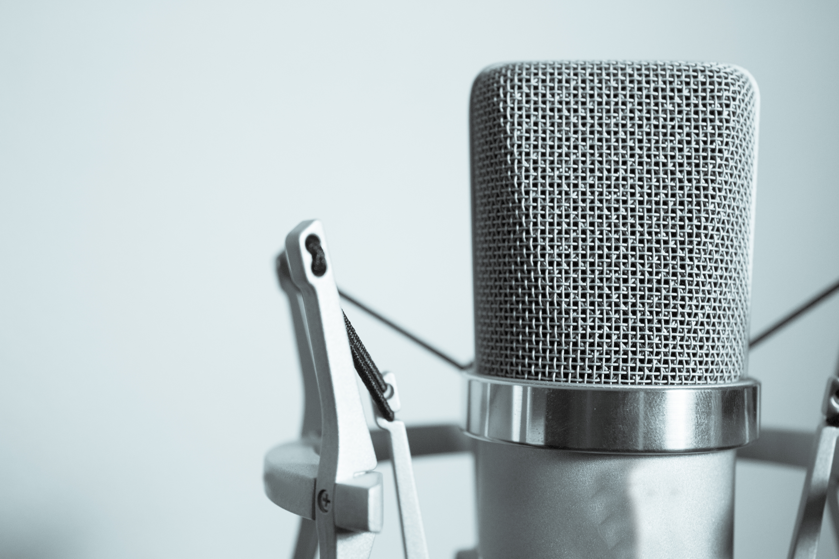
Which microphone are you going to use and why?

Where are you going to record your interview and why?

Where are you going to position your microphone?

How will you keep your mic nice and steady?

What equipment & resources do you need for the recording of your interview?
What are your final interview questions?
What do you need to consider from a health & safety perspective?

