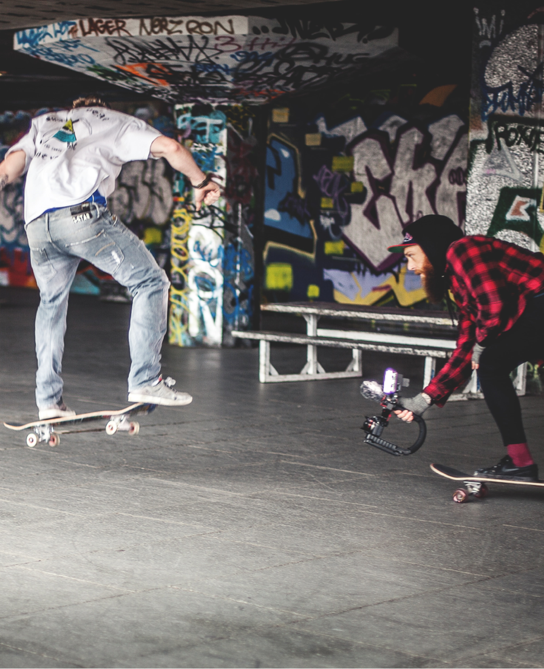

Project 1 – My Culture
Student Workbook
A1 Skills Development
L3 Creative Media Practice Y1 2021
Tutors: Thomas George, Michael Stephenson & Sophie Blount

Student Name: ………………………………………………………………...

Project Deadline: 10th January 2022

Contents:
Section 1 – Audio Production Skills
Section 2 – Photography & Graphic Design

Guide to using this workbook:
Upload this workbook to your personal OneDrive and add your own work to it via the live OneDrive document as instructed by the tutors in class and for homework tasks. DO NOT keep downloading the workbook to the desktop. As you progress through the assignment you will need to follow tutor guidance on which sections to complete next.

Section 1 – Audio Production Skills

Research:
Informing ideas
1.1 How I have interpreted the brief:

Research:
Informing ideas
1.2 How my audience research findings will inform my ideas

Research:
Informing ideas
1.3 How my research into industry podcasts will inform my own ideas

Research:
Informing ideas
1.4 How my research into youth culture will inform my ideas

Ideas Development:
Communication
1.5 My initial ideas for the project:

Ideas Development:
Communication
1.6 My final idea for the podcast:

Ideas Development:
Problem Solving
1.7 Challenges I may be faced with in relation to appealing to my target audience:

The problems that may occur during the planning & production of my final idea are...

I will overcome these problems by...

Ideas Development:
Technical Skills
1.8 My test audio recordings and edits:

Ideas Development:
Informing ideas
1.9 How the outcome of my test audio recordings and edits will inform my approach to this project

Pre-Production:
Professional Practice
1.10 How I plan to manage my time effectively to produce my podcast by the assigned deadline:

1.11 My script for podcast episode:

1.12 My equipment list for producing the podcast:

1.13 How I will manage hazards during the recording of my podcast:

1.14 Legal and Ethical considerations for my podcast idea:

1.15 How I will get my podcast out to the target audience:

1.16 Contingencies I will have in place in case parts of my idea fall through:

Pre-Production:
Professional Practice & Communication
1.17 My pitch in response to the brief:

Pre-Production:
Informing ideas
1.18 How the feedback from my pitch will inform the development of my ideas

Production:
Technical Skills
1.19 My edited intro & outro for the podcast episode:

Production:
Informing ideas & Problem Solving
1.20 My review and reflection of my edited intro & outro for the podcast episode

Production:
Problem Solving & Informing Ideas
1.21 Changes I have made to my plans to improve the final product:

Production:
Technical Skills & Professional Practice
1.22The process of recording my podcast:

Post-Production:
Technical Skills & Professional Practice
1.23 The process of editing my podcast:

Post-Production:
Technical Skills & Communication
1.24 My first draft of the edited podcast episode:

Post-Production:
Informing Ideas
1.25 Peer feedback for my podcast and what changes I will make to improve the final edit:

Post-Production:
Technical Skills & Communication
1.26 The final edited podcast episode:

Post-Production:
Problem Solving & Professional Practice
1.27 My final evaluation of the podcast and production process:

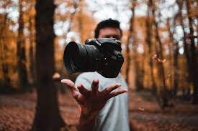
Section 2 – Photography & Graphic Design

Research:
Informing ideas
2.1 How I have interpreted the brief:

Research:
Informing ideas
2.2 How my audience research findings will inform my ideas

Research:
Informing ideas
2.3 How my research into industry photographers will inform my own ideas

Research:
Informing ideas
2.4 How my research into podcast artwork will inform my ideas

Ideas Development:
Communication
2.5 My initial ideas for the project:

Ideas Development:
Communication
2.6 My final idea for the podcast artwork:

Ideas Development:
Problem Solving
2.7 Challenges I may be faced with in relation to appealing to my target audience:

The problems that may occur during the planning & creation of my final idea are...

I will overcome these problems by...

Ideas Development:
Technical Skills
2.8 My test shoots and edits:

Ideas Development:
Informing ideas
2.9 How the outcome of my test shoots and edits will inform my approach to this project

Pre-Production:
Professional Practice
2.10 How I plan to manage my time effectively to produce my podcast artwork by the assigned deadline:

2.11 My sketches for podcast artwork:

2.12 My equipment list for producing the podcast artwork:

2.13 How I will manage hazards during the photoshoot:

2.14 Legal and Ethical considerations for my photoshoot idea:

2.15 Contingencies I will have in place in case parts of my idea fall through:

Pre-Production:
Professional Practice & Communication
2.16 My pitch in response to the brief:

Pre-Production:
Informing ideas
2.17 How the feedback from my pitch will inform the development of my ideas

Production:
Technical Skills
2.18 My test designs:

Production:
Informing ideas & Problem Solving
2.19 My review and reflection of my test designs:

Production:
Problem Solving & Informing Ideas
2.20 Changes I have made to my plans to improve the final product:

Production:
Technical Skills & Professional Practice
2.21 The process of shooting my images:

Post-Production:
Technical Skills & Professional Practice
2.22 The process of designing my podcast artwork:

Post-Production:
Technical Skills & Communication
2.23 The final design of my podcast artwork:

Post-Production:
Problem Solving & Professional Practice
2.24 My final evaluation of the podcast artwork and production process:

