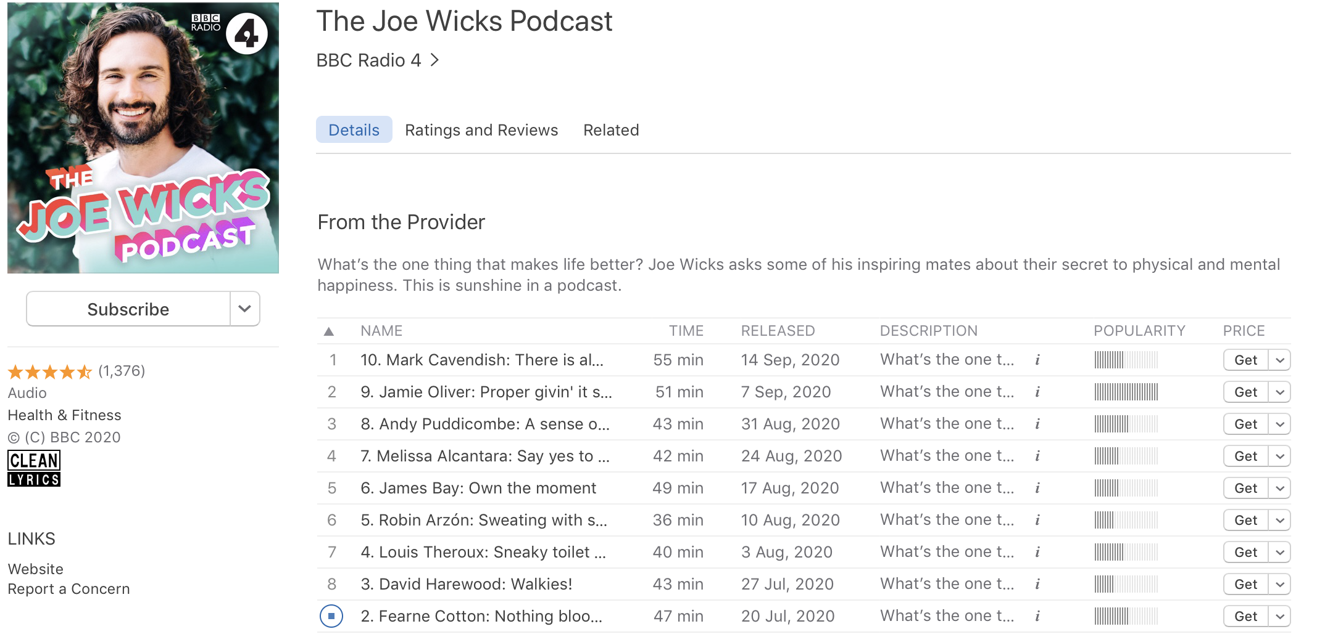
How does Joe Wicks start the podcast episode? What kind of things does he say?

What else can we hear at this point in the podcast?

What is the topic of this episode? How do we know this?

How does he introduce his guest?

How does the podcast end?

